Washington University in St. Louis
Percutaneous Mitral Regurgitation Repair
Progress Report
Group 24- Brooke Cheatham, Kaitlin Ayer, Tucker Krone
10/25/2011

Table of Contents
Background and Need 4
Design Specifications 5
Metric Design Specifications 6
Safety Design Specs 6
Patient Design Specs 6
Clinical Design Specs 7
Design Alternatives 7
Knot Tying Device 7
Design Specifications 8
Necessary items for procedure 8
Detailed Device Description 9
Procedure 10
Trap Device 11
Design Specifications 12
Necessary items for procedure 12
Detailed Device Description 12
Procedure 13
Shorts Device 14
Design Specifications 14
Necessary Items for Procedure 15
Detailed Device Description 15
Procedure 17
Box Model 19
Design Specifications 19
Necessary Items for Procedure 20
Detailed Device Description 21
Procedure 23
Delivery and Cinching Procedure 25
Cinching in the Shorts Device and Box Model 28
Criteria for Cinching Device 30
Scoring 32
Biocompatibility 32
Durability 32
Ease of Deployment 33
Ease of Adjustability 34
Mechanical Effectiveness 35
Cost 36
Pugh Chart Cinching Device 36
Chosen Design for Cinching Device 37
Box Model Force Calculations 37
Design Schedule 43
Team Responsibilities 43
Appendix 44
Material Analysis 44
Gore-Tex 44
316L Stainless Steel 44
L605 Cobalt Chromium 45
MP35N Cobalt Nickel 45
References 47

Background and Need
The mitral valve is a bi-leaflet valve and is the passageway between the left atrium and the left ventricle of the heart. The chordae tendineae are tendon-like chords that anchor the mitral valve leaflets to the papillary muscles. The chords prevent the leaflets from prolapsing into the left atrium. Mitral regurgitation (MR) happens when the mitral valve does not close completely and there is retrograde blood flow into the left atrium. When there is retrograde flow in the heart, the blood flow does not move efficiently through the heart, which reduces cardiac output and can cause shortness of breath (3).
Mitral regurgitation is the most common form of valvular heart disease. Two percent of the adult population suffers from mitral regurgitation with similar prevalence in males and females. There are 20,000 to 25,000 mitral valve procedures performed a year with an 80% success rate (3). However, only 44.3% of patients who have mitral regurgitation actually undergo mitral valve repair. This is due to the high complexity and risk factors associated with the current existing solutions to MR. Symptomatic patients have an annular death rate of 5% or more without intervention (2).
In the United States degenerative mitral valve disease is the most common cause of mitral regurgitation (4). Detached or elongated chordae of the posterior leaflet are the most common sources for mitral regurgitation, referred to as Type II MR, which is what our device is designed to fix (7). Mitral valve regurgitation is most often mild and progresses slowly. Severe mitral valve regurgitation can lead to heart failure, atrial fibrillation, endocarditis, and pulmonary hypertension. There is a positive feedback loop associated with mitral regurgitation. Mild MR leads to less blood flow in the body, which leads to less oxygen circulation. Receptors in the heart sense the lack of oxygen flow and therefore dilate the annulus of the valve. This leads to poorer valvular function, which in turn leads to a greater retrograde flow in the heart, which increasingly contributes to the positive feedback loop. Therefore valvular repair should be recommended for patients with mild mitral regurgitation because the condition will become progressively worse with time (1). However, currently the guidelines recommend surgery for moderate-to-severe or severe MR in patients with symptoms or indication of left ventricular dysfunction (2). Our device is designed to fix minimal MR without the side effects and risks associated with current procedures.
Our design project is focused on providing a minimally invasive percutaneous Type II MR repair. Our project is the final step in a three-step process to repair Type II MR. The first step (completed in 2009) involves anchoring the artificial chordae to the mitral leaflet. The second step (completed in 2010) requires attaching a separate chordae to the left ventricle wall. The focus of our project is to design a adjusts the lengths of the artificial chordae tendineae (ACT) and then cinches the ACT in order to reduce MR (3).

Design Specifications
Our design specifications are broken up into:
- Metric design specifications
- Safety design specifications
- Patient design specifications
- Clinical design specifications

Metric Design Specifications
- ACT Tear strength ≥ 9.8 N (1,000 g)
- ACT Clipped strength ≥ 4.9 N (500 g)
- Length of ACT: 30-45 mm
- Device should allow leaflet to open 1mm when there is a force of 14 N applied to the leaflet
- Diameter of femoral artery: 8.2–12.7 mm
- Diameter of catheter: ≤ 24 French (8 mm)
- Diameter of cinching device < Diameter of catheter
- Selling price: $27,000

Safety Design Specs
- Biocompatible
- Durable
- Does not inhibit blood flow
- Does not inhibit heart motion
- Does not inhibit electrical signals
  - In the body
  - EKG

Patient Design Specs
- Last the remaining life of the patient
- Minimize possibility of blood clots
- Once the artificial chordae are cut, no sharp edges may be present

Clinical Design Specs
- The lengths of the artificial chordae must be adjustable before cinching
- Easily operable by a single physician
- Procedure < 1 hour long
- Must integrate with a catheter delivery system
- Able to move within the left ventricle to be able to cinch the chordae tendineae (CT) where needed
- Catheter and artificial chordae tendineae must be visible under fluoroscopy and Transesophageal Echocardiography (TEE)

Design Alternatives
Our four design alternatives for our cinching device are:
1. A Knot Tying Device
2. A Trap Device
3. Shorts Device
4. Box Model

Knot Tying Device
The knot tying device is broken into:
- Design specifications
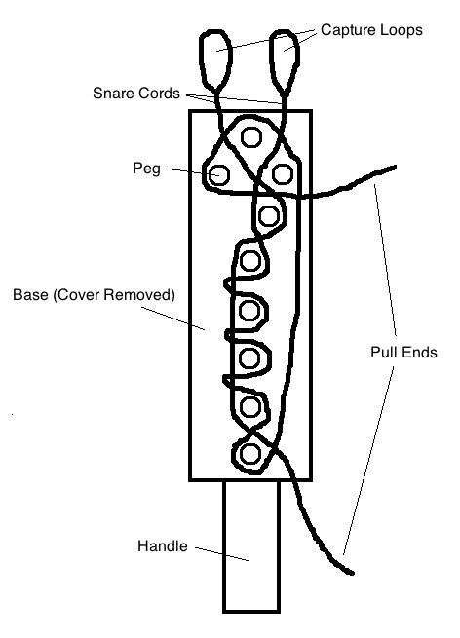
- Necessary items for procedure
- Detailed device description
- Procedure

Design Specifications
- Device material: 316L stainless steel.
- ACT material: Gore-Tex.
- Width: 8.0 mm (24 French); Length: 2.6 cm (78 French); Depth: 6.0 mm (18 French); Handle length: 1.0 cm (30 French).
Figure 1: Knot Tying Device
- Number of pegs: 9; Height of pegs: 6.0 mm (18 French); Diameter of pegs: 1.0 mm (3 French); Spacing between pegs: 2.0 mm (6 French)
- Snare cord material: non-degradable, synthetic (polypropylene, polyester, or nylon) sutures.

Necessary items for procedure
- ACT – one attached to the leaflet and one attached to the papillary muscle.
- 24 French catheter.
- Mechanical clamp guide wire
- Guide wire with clipping component.

Detailed Device Description
A knot tying device is a possible method of configuring the ends of the ACT into a knot. The device is comprised of a hollow box with a removable cover. Both the base and the cover of the box are made of 316L stainless steel. Within the box are small steel pegs that are attached to the base and extend up towards the cover. A pair of snare cords are weaved through the guide pegs within the knotting device to form a loose knot pattern. The removable cover has holes in it that match with the positions of the pegs.
When the device is initially made, the pegs are attached to the base in such as way as to make the type of knot desired. The type of knot that will most likely be used to tie together the cords is a Surgeon’s Knot, also called a Friction Knot, because it is designed to hold under tension. In order to form a Surgeon’s Knot, the pegs are configured as shown in Figure 1. If the chordae are made of 5.0 Gore-Tex (diameter of 5.0 French, or 1.667 mm), the pegs need to be approximately 2.0 mm (6 French) apart to allow for the Gore-Tex cords to weave between them. Additionally, the base and the pegs will have a height of 6.0 mm (18 French) so that the Gore-Tex cords have space to slide easily on top of one another within the device. The pegs themselves will have a diameter of 1.0 mm. In order to accommodate the pegs in their appropriate positions, the device needs to have a width of 8.0 mm and a length of 2.6 cm. The device has a handle extending 1.0 cm from its short edge (8.0 mm edge) so that the device can be gripped and maneuvered during the procedure. This handle allows for a guide wire with a mechanical clamp component to grip the device so that the device can be maneuvered through the catheter and positioned in the left ventricle.
The snare cords weave through the knotting device and extend out of the box through holes in the sides of the device. The snare cords are non-degradable, synthetic sutures that are strong and stiff yet flexible enough to be knotted. One end of each snare cord is designed to capture a loose end of the ACT. The capture ends of the snare cords are made into loops – the cord doubles back and ties to itself, forming a small loop. The other ends of the snare cords extending straight out from the box are the pull ends. Both cords are configured through the pegs in partial knot patterns that are complementary of each other so that together the cords form a full knot. This knot, though, is loose so that each of the cords can be pulled through the knotting guide.

Procedure
After the ACTs have been attached to the leaflet and the papillary muscle, they are pulled through the aortic arch and out of the femoral artery through the catheter. The following steps are then taken to cinch the ACTs.
- Feed the ends of the chordae through the knot tying device while outside of the body. This is done by feeding the ends of the chordae through the capture loops of the snare cords.
- Pull the snare cords by their pull ends through the knotting guide, either sequentially or simultaneously, thereby pulling the CT ends through the knotting guide. Through this method, the CT ends are configured in the loose knot pattern that the snare cords were originally positioned in.
- Discard the snare cords outside of the body.
- Push the knot tying device along the chordae through the catheter using a mechanical clamp guide wire attached to the handle of the device. With a width of 8.0 mm, a 24 French catheter is needed to insert the device into the body. A 24 French catheter is the largest catheter we are willing to use in the femoral artery, as it is the narrowest point of the catheterization pathway. The femoral artery is between 8.2 mm- 12.7 mm in diameter.
- Guide the device into the left ventricle.
- Pull the chordae through the device until they are as tight as desired. The desired tightness is gaged by the physician observing when minimal MR is achieved on TEE.
- Remove the cover from the box using the mechanical clamp guide wire.
- Remove the knot from the knotting guide and tighten the knot. The slack in the loose knot needs to be accounted for when determining where to position the knot in order to achieve the desired tension in the chordae.
- Cut the excess parts of the cords near the knot using miniature clippers guided into the heart from the catheter.
- Remove the excess cords, the knotting device, the clamp, and the clippers from the body.

Trap Device
The trap device is broken into:
- Design specifications
- Necessary items for procedure
- Detailed device description
- Procedure

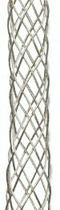
Design Specifications
- Device material: 316L stainless steel wire mesh.
- When elongated, the length is 2.0 cm (60.0 French) and the diameter is 3.33 mm (5.0 French). When relaxed, the length is 1.8 cm (54.0 French) and the diameter is 5.33 mm (16.0 French).
- Intended to be used with ACT made of Gore-Tex or another flexible material that can be gripped by stainless steel.
Figure 2: Trap Device

Necessary items for procedure
- ACT – one attached to the leaflet and one attached to the papillary muscle.
- 18 French catheter.
- Mechanical clamp guide wire.
- A guide wire with clipping component.

Detailed Device Description
A trapping device with grip could be used to connect the two ends of the ACT. Essentially, the device is a miniature Chinese finger trap, as shown in Figure 2. This surgical trap is constructed with 316L stainless steel wire mesh. As the device is elongated, the wire mesh tightens together and the diameter of the device becomes smaller. The diameter of the device, when fully elongated, is 3.33 mm so that the wire mesh closes tightly around the two Gore-Tex cords (each a diameter of 1.667 mm) that are fed through the device. When the leaflet opens and the ACT loosens, the diameter of the wire mesh trap increases and the length of the device decreases. When the leaflet closes again the device then lengthens to 2.0 cm, its fully elongated state. Natural CT are approximately 4.0 cm in length, so the 2.0 cm elongated device will fit along the ACT without coming in contact with the left ventricle or leaflet and will allow for substantial surface area contact between the wire mesh and the chordae. The surface of the steel on the inside of the trap is grooved, or uneven, so as to provide additional grip on the chordae.

Procedure
After the ACTs have been attached to the leaflet and the papillary muscle, they are pulled through the aortic arch and out of the femoral artery through the catheter. The following steps are then taken to attach the chordae.
- Feed the ends of the chordae through the trap device while outside of the body. The ends of the cords are fed into opposite openings of the device and exit out opposite ends of the device.
- While holding the cord ends outside of the body, guide the trap device along the cords through the catheter using a mechanical clamp guide wire. Keep the device in its relaxed state while it is guided through the body into the left ventricle. Because the device has a relaxed diameter of 5.33 mm (16.0 French), a catheter of 18 French is used in order to leave movability for the physician when inserted the device
- Once inside the left ventricle, pull the chordae through the device until they are as tight as desired. The desired tightness is gaged by the physician observing when minimal MR is achieved on TEE.
- Elongate the mesh trap using the mechanical clamp to extend the ends of the device outward until the device has completely closed around the cords.
- Cut the excess cord ends extending out from the device using a guide wire with a clipping component.
- Remove the excess cords, the clamp, and the clippers from the body.

Shorts Device
The shorts device is broken into:
- Design specifications
- Necessary items for procedure
- Detailed device description
- Procedure

Design Specifications
- Cord Material: 316L stainless steel
- Device Material: Polypropylene (PP)
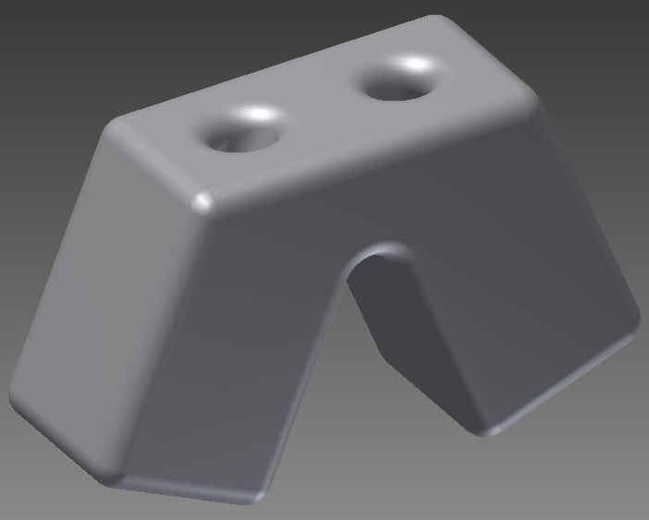
- 3 mm (9 French) deep
- 2 mm (6 French) wide
- 2 mm (6 French) tall
- The holes are centered on the end of each sleeve and have a diameter of 0.5 mm (1.5 French).
- The holes extend all the way through the sleeve until they come out the back
Figure 4: Shorts Device
- Diameter of 316L grade stainless steel cord: 0.5 mm
- Push buttons to activated cinching device on each sleeve of the shorts (not shown in diagram)
- Spring initiated cinching device inside shorts device on each sleeve of the shorts

Necessary Items for Procedure
- Artificial chordae: one attached to the leaflet and one attached to the papillary muscle.
- 18 French delivery catheter
- U-shaped guide wire
- 2 mechanical clamp guide wires

Detailed Device Description
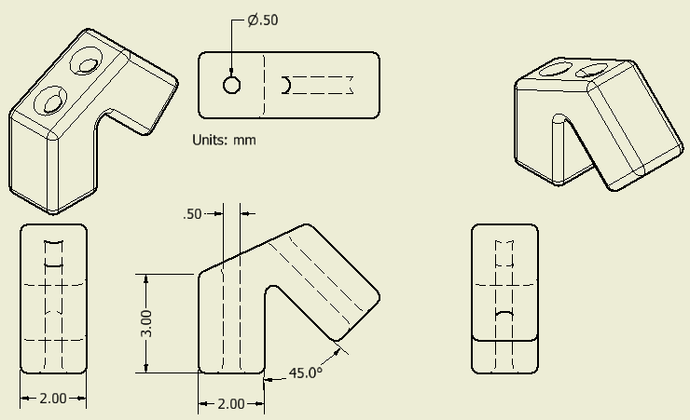
Figure 5: Dimensions of Shorts Device
Figure 5 shows the dimensions of the sleeve shape of the shorts device. The sleeve shape incorporates the elasticity needed in the entire artificial system. The cords will be made of an inelastic material, 316L grade stainless steel specifically, and the shorts themselves are made of polypropylene (PP) that allows them to flex along the angle between the sleeves. Polypropylene can be used in artificial heart valve structures and is therefore appropriately biocompatible for the heart. Figure 6 shows how the shorts device helps reduce MR. 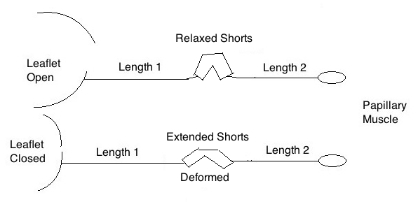
Figure 6: Relaxation and expansion of the shorts device when the mitral valve opens and closes, respectively.

The shorts device is deployed and cinched in its expanded state when the mitral valve is closed. The shorts device is deployed in an expanded sate by dimensioning the mechanical guide wires (which are attached to the push buttons) to hold the shorts at the expanded sate that is desired when cinching. When the mitral valve opens the angle between the shorts decreases to its relaxed state. The pressure differential from the left atrium to the left ventricle causes the opening and closing of the mitral valve. When the mitral valve closes, the blood pressure from the LV applies a force along the chordae and the shorts device responds to the force by increasing the angle between the sleeves. When the pressure is greater in the left atrium than the left ventricle the mitral valve opens and the shorts device relaxes, thereby decreasing the angle.
There is a cinching mechanism on the inside the shorts device on each sleeve. Each cinching mechanism has two push buttons on the outside of each sleeve. The cinching mechanism cinches the steel cords close to the exit holes of the steel cords on each sleeve of the device. The cinching mechanism is designed to fit snuggly around the 316L stainless steel. The cinching of the shorts device is initiated by the physician with two mechanical clamp guide wires, which fit snuggly around the push buttons on the sleeves of the shorts. Cinching is initiated when the mitral valve is closed and MR is minimal on the TEE.

Procedure
After the ACTs have been attached to the leaflet and the papillary muscle, they are pulled through the aortic arch and out of the femoral artery through the catheter. The following steps are then taken to cinch the ACTs.
- Feed the ends of the chordae through sleeve 1 and sleeve 2 and out the waist on the opposite side. This is shown in Figure 7 and is done outside of the patient’s body.
- Position the two mechanical clamp guide wires on sleeve 1 and sleeve 2 on the push buttons of the shorts device.
- Push the device through the femoral artery and into the heart with the U-shaped guide wire positioned along the waist with the sleeves pointed towards the heart. The mechanical guide wire clamps are also attached to the push buttons. This is shown in Figure 7 without the U-shaped guide wire and the 2 mechanical guide wires attached. (The U-shaped guide wire and 2 mechanical guide wires are similar to the ones shown for the box model in Figure 13 and Figure 15, respectively.)
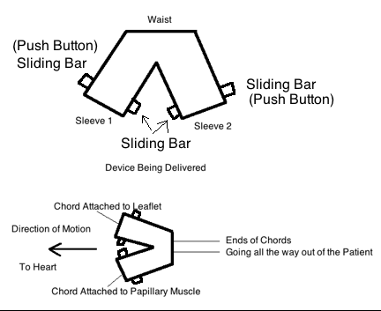
Figure 7
Top: Diagram of shorts device
Bottom: How ACTs are threaded into shorts device and guided into the patient
- Once the device is in place, the chords are adjusted to the correct length by the surgeon using the U-shaped guide wire, while the surgeon watches the patient’s MR using TEE.
- The surgeon then promptly cuts and cinches the chords when mitral regurgitation is minimized. The mechanical clamp guide wire squeezes the push buttons on the sleeves which then clamp onto the steel cords inside the shorts accomplish the cinching. The cinching device is identical to the cinching device inside the box model and is described in the box model design description.
- There are two options to cut the chords. The cutting mechanism can either be inside the shorts device or it could be a separate step in the process.
  - If the cutting mechanism is inside the device, then it would act like a cigar cutter half way through the path of the holes.
  - If it is a separate step in the process, then the cutting device would be inserted into the patient using a guide wire with a clipping device.

Box Model
The box model is broken into:
- Design specifications
- Necessary items for procedure
- Detailed device description
- Procedure

Design Specifications
- Cord, Box and Spring Material: 316L stainless steel
- Boxes are 2x2x2 mm (6x6x6 French) cubes
- Boxes are connected by a spring of length 1 mm (3 French) in the relaxed state
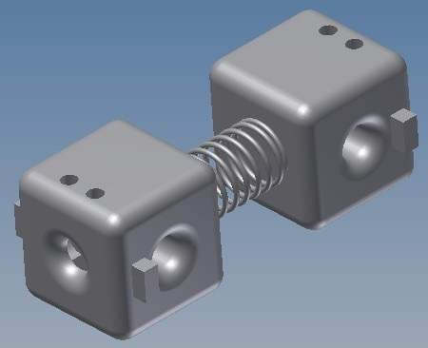
- The spring is designed to be extended ~1 mm (3 French) during heart contraction
- The spring’s standard extended length will be about 2 mm (6 French) long
- The four holes are centered on the face of the cube they are on and have a diameter of 0.5 mm (1.5 French)
Figure 8: Box Model
- The holes meet and extend straight to the middle of the cube
- Diameter of 316L stainless steel cord: 0.5 mm
- Diameter of spring: 1 mm (3 French)
- Push buttons which activate the cinching device on each box.

Necessary Items for Procedure
- Artificial chordae: one attached to the leaflet and one attached to the papillary muscle
- 20 French catheter delivery
- A U-shaped delivery guide wire that has a notch with a 1 mm diameter and a length of 2 mm. It will clip to the whole length of the extended spring during delivers so the spring is deployed in its extended state.
- Two mechanical clamp guide wires

Detailed Device Description
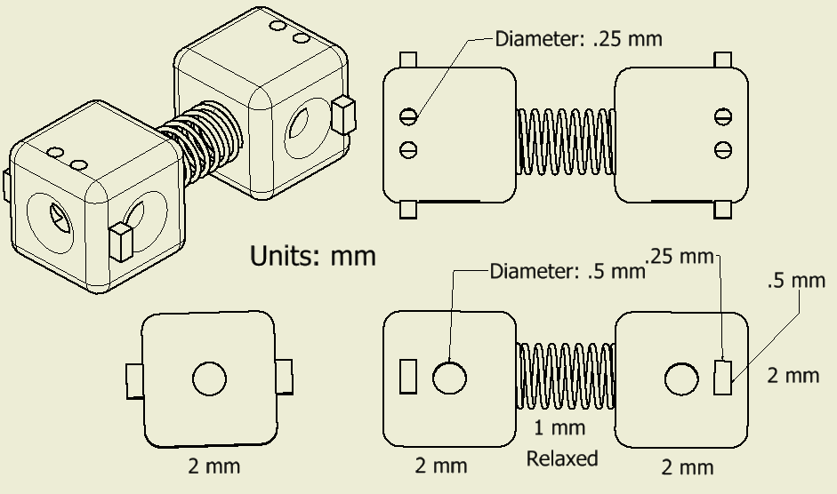
Figure 9: Dimensions of Box Model
The box model involves two small boxes that have the cords threaded through them and are connected by a spring. The boxes are in line with each other and they each have a hole on the opposite side of the connecting spring.
The goal of the device design is to have the cords and device completely in line with one another. The straight-line design of the device allows all of the force to move the boxes. The boxes are made of a rigid material, specifically 316L stainless steel, so the extension of the system is completely accounted for by the spring.
The spring is deployed and cinched in its extended state when the mitral valve is closed. The spring is in its relaxed state when the mitral valve is open. The spring is deployed in its extended sate by using a specifically dimensioned U-shaped guide wire that fits around the spring and keeps it extended as the physician deploys the box model. When the mitral valve opens the spring length decreases to its relaxed state. When blood flows from the left atrium into the LV, the posterior leaflet opens into the LV and decreases the distance between the leaflet and the papillary muscle. The decrease in distance is accomplished by the decreased length of the spring returning to its relaxed state. When the posterior valve is supposed to be closed, the spring is extended because it responds to the force inside the LV.
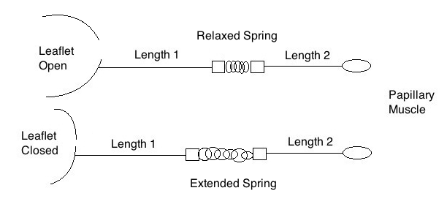
Figure 10: Diagram of how the Box Model reduces MR with spring extended when the mitral valve is closed and the spring relaxed when mitral valve is open.
Type II mitral regurgitation occurs when the leaflet has exaggerated motion and extends into the left atrium when it should be closed. The spring helps close the leaflet as the force from the left ventricle increases, shown in Figure 11. The spring applies a slight force against the leaflet to ensure mitral regurgitation does not occur.
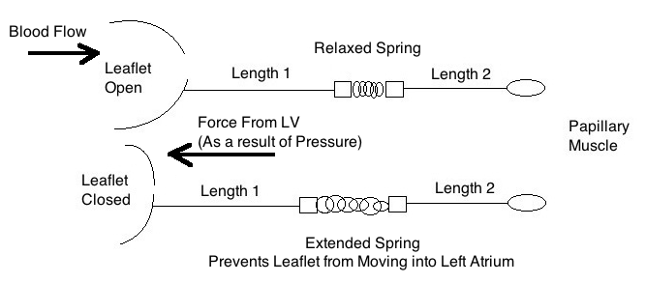
Figure 11: Diagram showing forces and blood flow of how the spring reduces MR with an extended spring when the mitral valve is closed and the spring relaxed when mitral valve is open.
Only a spring component is needed to adjust for the change in length because the heart follows elastic motion, not visco-elastic motion. The spring responds instantaneously to an applied force, which allows blood to flow into the heart and for the spring to close in response to LV blood pressure. The relaxed state of the spring creates resistance to an applied force to ensure complete closure of the leaflet. The spring’s relaxed state allows normal blood flow into the heart when the leaflet is open. The spring allows the artificial system to change in length as the applied force from the left ventricle changes. The calculated spring constants are 12,000 N/m for normal blood pressure and 14,000 N/m for a patient with hypertension to make the artificial system simulate biological chordae tendinae and heart motion. The spring constant is calculated in the following section, Box Model Force Calculation, with the intention of the relaxed state to be the minimum length. The extended state is extended by a physiological amount by the calculated force of blood in the LV.

Procedure
After the ACTs have been attached to the leaflet and the papillary muscle, they are pulled through the aortic arch and out of the femoral artery through the catheter. The following steps are then taken to cinch the ACTs.
- Thread the ACTs through the holes on the opposite sides from the spring and out the holes facing the same side.
- Place the U-shaped guide wire around the spring, with the spring horizontal to the length of the femoral artery as shown in Figure 12.
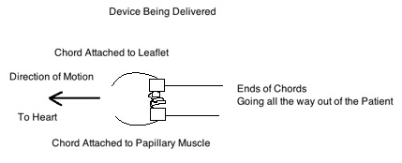
Figure 12: Diagram of how ACTs are threaded into the Box Model and the direction the Box Model is inserted into the femoral artery.
- Once the device is in place, adjust the cords to the correct length using the U-shaped guide wire to push the device. In order to determine the correct length the physician watches when MR is minimal on the TEE.
The chords are not anchored to the device yet, but the length of the whole system is preserved because the boxes are connected by the spring in its extended state and none of the forces go through the spring until the chords are cinched. The U-shaped guide wire keeps the spring in its extended state. The chords have to be cinched when the leaflet is closed because that is when mitral regurgitation is visible. The cinching will occur flush with the hole opposite the spring. The cinching mechanism is described below. The cinching mechanism is the same as the cinching mechanism for the Shorts Device.
- There are two options to cut the chords. The cutting mechanism can either be inside the shorts device or it could be a separate step in the process.
  - If the cutting mechanism is inside the boxes, the chords will be cut slightly deeper into the device and then the remaining chord will be pulled through the holes that face the same direction and out of the patient.
  - If it is a separate step in the process, then the cutting device would be inserted into the patient using a catheter system.

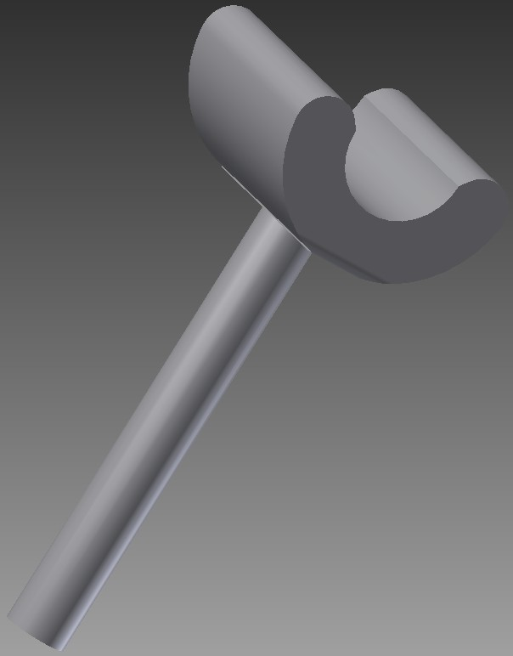
Delivery and Cinching Procedure
Specifications
- Material: Stainless steel
- U-shaped delivery guide wire that has a notch with a 1 mm diameter and a length of 2 mm. It will bind to the whole length of the extended spring during delivers so it is deployed in the extended state.
A custom guide wire similar to the one shown in Figure will be used to deliver the Shorts Device as well. The U-shaped guide wire will be made of 316L stainless steel. For the Shorts Device, it will clip onto the sides of the device so the guide wire will not inhibit the cords. For the Box Model, the guide wire will clip across the extended spring, length 2 mm. The delivery device clips across the whole spring so the spring does not deform during delivery. The U-shaped guide wire for the device that spans the whole spring is shown in Figure 13. The bar of the delivery system goes all the way out of the patient.
Figure 13: U-shaped guide wire
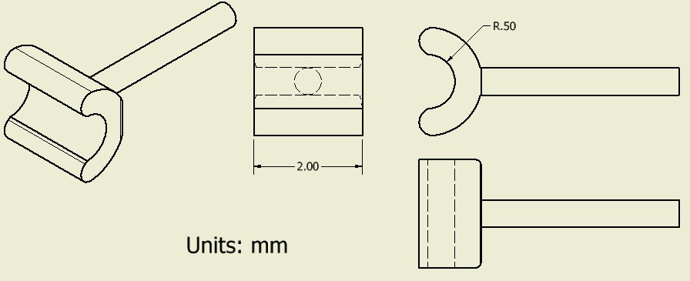
Figure 14: Dimensions of U-shaped guide wire
The guide wire pushes the devices to the desired position within the LV. After the cords are cinched, the guide wire will be pulled, disconnected and removed from the patient’s body. The cinching device will remain in place inside the device.
The guide wire clamp that press the push buttons in to cinch the cord has the following design shown in Figure 15 and Figure 16.
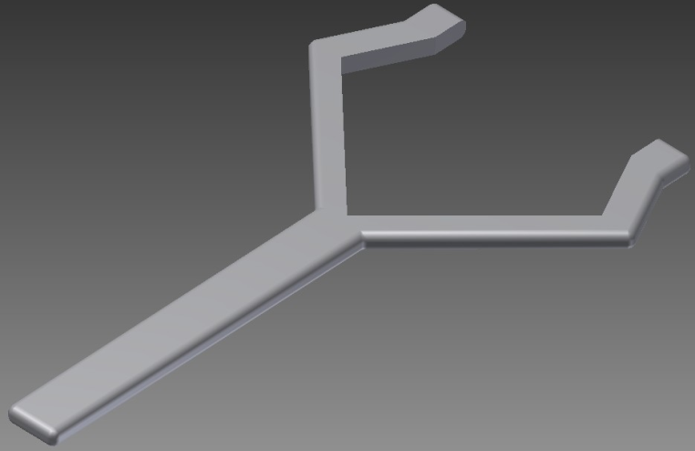
Figure 15: Guide wire clamp
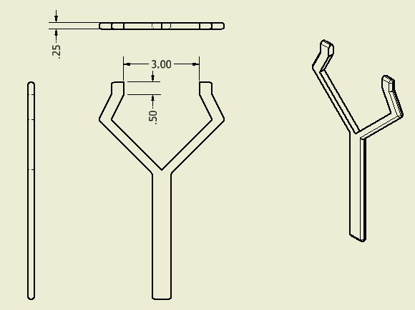
Figure 16: Dimensions of guide wire clamp
There is one guide wire clamp for each of the cords in the device. A picture of all the U-shaped (delivery) guide wire and guide wire clamp delivery of the Box Model is shown in Figure 17.
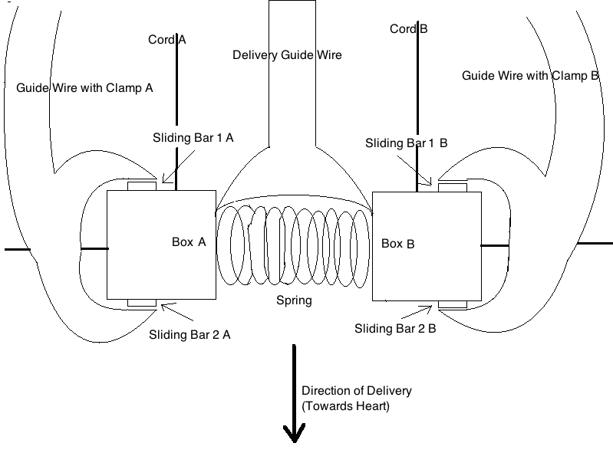
Figure 17: Delivery system of the Box Model, including Delivery guide wire and 2 guide wire clamps

Cinching in the Shorts Device and Box Model
Specifications
- Shorts Device:
  - Sliding bars and push button are made of polypropylene
  - Spring is made of 316L stainless steel
- Box Model
  - Sliding bars, push buttons and springs are all made of 316L stainless steel
- Diameter of steel cord: 0.5 mm
- Diameter of grooved gripping section: 0.5 mm
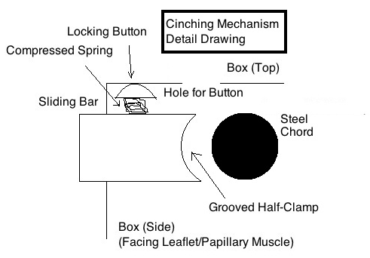
The cinching device is a clamp that slides into place and is then secured. Figure 18 shows a detailed drawing of the different components of the cinching mechanism. The drawing is done facing the side where the cord needs to be cinched flush to on the inside. An internal look into the Box Model is shown in Figure 18.
Figure 18: Cinching device in Box Model
The curved surface in Figure 18 is grooved to be able to secure the steel cord. The curved surface works like pliers. The grooves create friction and ensure the steel cord does not slip because the diameter of the whole clamp (both sides included) is exactly the same as the diameter of the cord (0.5 mm).
The button on the top is compressed while the device is deployed and the cords are adjusted. Once the desired cord length is achieved, the sliding bar is pressed into the device towards the steel cord by the guide wire clamp that is on the device while it is being deployed by the delivery guide wire that fits the spring. The button is attached to the sliding bar at a specific location. As the bar slides, so does the button. Once the button reaches the hole, the compressed spring extends and the button holds the sliding bar in place. Both sliding bars move in and towards the steel cord at the same time to ensure the steel cord is centered in the clamping device. The clamping guide wires are a separate device and forces the sliding bars to cinch the cord. Figure 19 shows the un-cinched and cinched states of the cinching mechanism.

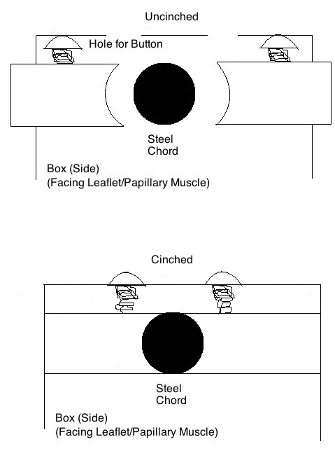
Criteria for Cinching Device
Figure 19
Top: Un-cinched Box model in order to adjust ACT length
Bottom: Cinched Box model, which hold the ACT in a fixed place

The cinching device was scored according to the following design criteria: Biocompatibility, Durability, Ease of Deployment, Ease of Adjustability, Mechanical Effectiveness, and Cost. Our cinching device is designed to remain in the patient’s body for the duration of his/her life and therefore must be biocompatible in order to avoid a negative immune response. The device needs to be durable so the mechanism does not degrade or become loose over time. Ease of Deployment is an important criterion we investigated in insuring the physician can maneuver the catheter attached to the device with ease. The device must be capable of being threaded or pushed with a guide wire into the femoral artery, around the aortic arch, and into the left ventricle. The ACTs also need to be adjustable to the correct lengths where the cords will be cinched. Our goal is reduce MR and in order to do so the device need to be mechanically effective. Our criteria for mechanical effectiveness are: ability to replicate physiological tensions in the CT, ability to replicate change in length of the CT, and ability to undergo this change in length as slow as when the heart is at rest and as fast as when the heart is under maximum exertion. Finally we want to minimize cost, so we looked into the cost of production, materials and delivery systems we would need for each cinching mechanism.
We next weighted each of the above criterion on a scale of 1-10 based on its importance for our patients’ needs. We assigned weights of 10 to the following criteria: Biocompatibility and Durability. We must make sure that our device does not cause any negative side effects to the patient, and the health of the patient post-procedure is our number one concern. Therefore, we must be certain that the device that we choose will not affect the patient’s immune system and will work properly for a long duration. The Mechanical Effectiveness and Ease of Adjustability were rated a 9 because it is high on our list of priorities in term of reducing MR, however it does not have the ability to affect that patient negatively post operatively as the other criteria rated as 10. The Ease of Deployment criterion was weighted 8 because this criterion is based on the ease of the surgery for the doctor. Marketing our device to appeal to physicians performing the surgery is very important in terms of getting our product to market. However, we felt that the ease of surgery is of lesser importance than the safety of the patients. Lastly, we weighted Cost 6 because we found it to be of lesser importance than the physicians’ ease of surgery but still and important criterion in terms of getting our product to market.

Scoring
We scored our four design concepts on a scale from 1-10 based on the criteria above. In the Pugh Chart below, Green represents a perfect score (10), yellow a high score (9-7), and red a low score (6 and below).

Biocompatibility
The Knot Tying Device, Trap Device, and Box Model are all made of 316L stainless steel. The Shorts Device is made of Prolypropylene (PP). The Knot Tying Device and the Trap Device use Gore-Tex as the material for the ACT. The Shorts Device and the Box Model use 316L stainless steel, the same material as the device, for the ACT. There is a possibility that the devices using 316L stainless steel would require the patients to use blood thinners. Stents are of a comparable size to our devices so we anticipate the patient will need to take aspirin and go on blood thinners for approximately 1 to 12 months as that is what patients who have stents need post-operatively. Gore-Tex does not require the patient to go on blood thinners so we rated the Knot Tying Device a 10 in biocompatibility, because the stainless steel device is removed from the patient and only the Gore-Tex ACT remains in the patient permanently. We rated the Trap Device, Box Model, and Shorts Device a 9 for biocompatibility due to the prospect of the patient requiring blood thinners.

Durability
The Knot Tying Device is rated a 7 for durability because Gore-Tex does not hold onto the papillary muscle and leaflet as well as 316L stainless steel. Therefore, overtime there is a chance that the ACT will detach from the leaflet or papillary muscle. The Trap Device is rated a 3 in durability because of the large potential of the Gore-Tex slipping in the wire mesh trap. When the mitral valve opens, the diameter of the trap increases. This causes room for the Gore-Tex to move, therefore changing the lengths of the ACT and reducing the success rate of minimizing MR. There is also the potential of the Gore-Tex detaching from the leaflet or papillary muscle for the same reason as the Knot Tying Device. The Shorts Device ACT is made out of 316L stainless steel. Therefore, there is strong anchoring to the papillary muscle and leaflet. However, the device itself is made out of PP which is not as durable as 316L stainless steel and has the potential to wear over time due to the rubbing of the stainless steal against the PP surface. Due to this concern, we rated the Shorts Device a 6 in durability. For the Box Model, both the ACT and the device itself are made out of 316L stainless steel, which is very durable. We do not anticipate any detachment of the ACT from the leaflet or the papillary muscle due to the flower hook stainless steel attachment to the leaflet and papillary muscle (completed in 2010). All elements in the Box Model: spring, boxes, buttons, and sliding bars, are made of 316L stainless steel and therefore is the most durable system of our four designs. We rated the Box Model a 10 in durability.

Ease of Deployment
Ease of deployment scores were given based on the ability for the physician to insert and cinch the device with minimal complications. We looked at the catheter size and mechanics of the cinching mechanism in order to determine ease of deployment scoring. The smaller the catheter the easier it is for the physician to maneuver the device over the aortic arch. The Knot Tying Device was scored a 5 for ease of deployment. The Knot Tying Device is 8 mm wide requiring a 24F catheter (the largest catheter able to fit into the femoral artery). The Knot Tying device fits snugly into the 24F catheter, which could cause difficulties for the physician in pushing the Knot Tying device through the catheter. The Knot Tying Device also requires a removal of the cap, which is an extra step for the physician and requires higher-level skill. The Trap Device requires 18 F catheter in order for the trap device to be inserted into the femoral artery lengthwise. Once the Trap Device is in the LV, the physician must turn the device so it is oriented lengthwise with the papillary muscle and leaflet. The turning of the Trap Device requires the physician to torque the guide wire to create a hook or to use a guide wire with a mechanical clamp component. This extra complexity to the deployment of the Trap Device causes the Trap Device to have a score of 6 for ease of deployment. The Shorts Device requires an 18 F catheter, the same size as the Trap Device. The Shorts Device has minimal movability for the clamps to fits around the push buttons The Shorts Device are at an angle and therefore causes the clamping devices to have minimal movability during deployment. We rated ease of deployment a 7 because we believe the minimal movability will cause higher skill from the physician, but will not be as difficult as turning the Trap Device. The Box Model requires a 20 F catheter and requires two guide wire clamps that have more movability for the physician than the Shorts Device, due to the angle of the Shorts Device restricting movement of the clamps. The Box Model requires a larger catheter than the Shorts Device, 20 F and 18 F, respectively. We scored the Box Model a 9 for ease of deployment, marking off one point for the larger catheter size.

Ease of Adjustability
The Knot Device is given the lowest rating for ease of adjustability (score of 3) because the physician has minimal control over the slack that is in the knot created in the Knot Tying Device. Therefore, the physician may want to cinch and a certain length, but due to the slack in the knot it is cinched at a different length than anticipated. The Trap Device is given a score of 6 for ease of adjustability, because we anticipated complications associated with threading the ACT through the Trap Device lengthwise. This way of threading causes one ACT to be wrapped around the Trap Device, which could lead to issues of adjustability once inside the LV. The Shorts Device and Box Model both used the U-shaped guide wire in order to adjust the lengths of the ACT. This method is the easiest for the physician to control. Once in the LV, the physician guides the Shorts and Box Model with the custom designed U-shaped guide wire until there is minimal MR on the TEE. We scored the Shorts Device and the Box Model a 9 for ease of adjustability.

Mechanical Effectiveness
Mechanical Effectiveness is rated on the ability of the device to replicate the physiological condition of the heart with minimal MR. The Knot Tying Device is given a scoring of 5 because it has no component that accounts for the force and change in length. It is just a string of Gore-Tex tied with a knot. The Trap Device is scored a 3 because there is no component in the Trap Device that accounts for the force and change in length, but there is also the element of slippage, which drastically decreases the mechanical effectiveness of the Trap Device. The amterial of the Shorts Device, PP, accounts for the elasticity of the chordae. However, the Shorts Device has a non-direct force transfer with non-natural angles, instead of a straight shot from the leaflet to the papillary muscle. Due to this setback the Shorts Device was given a score of 7. The Box model has a perfect score because the spring component adjusts for the change in length of the elastic motion of the valve. The spring responds instantaneously to an applied force, which allows blood to flow into the heart. This replicates the physiological condition of the heart. We also included two different springs, one for patients with hypertension and one for patients with normal blood pressure.

Cost
Cost was based on the material of the device and other devices needed to implement the device. The Knot Tying Device, Trap Device and Shorts were all rated similarly for cost (score of 9) due to similar materials used. We anticipated the Box Model to be more expensive because of the two custom springs that need to be manufactured. This is why the Box Model is scored a 6 for cost.

Pugh Chart Cinching Device
Figure 20: Pugh Chart Analysis for Cinching Device. Scores are weighted based on importance with green indicating a perfect score (10), yellow a high score (9-7) and red a low score (6 or below).

Criteria | Weight | Knot Tying | Trap | Shorts | Box
Biocompatibility | 10 | 10 | 9 | 9 | 9
Durability | 10 | 7 | 3 | 6 | 10
Ease of Deployment | 8 | 5 | 6 | 7 | 9
Ease of Adjustability | 9 | 3 | 6 | 9 | 9
Mechanical Effectiveness | 9 | 5 | 3 | 7 | 10
Cost | 6 | 9 | 9 | 9 | 6
Total |  | 336 | 303 | 404 | 469

Chosen Design for Cinching Device
We chose the Box Model as our design because of its high Pugh Chart score of 469. Despite the expected higher cost, this model offers the safest approach and replicates the physiological conditions of the heart the best.

Box Model Force Calculations
The Box Model uses a spring to push the mitral leaflet closed that is experiencing posterior mitral regurgitation. The spring is at its relaxed state when the mitral leaflet is open.
Following Kara’s and Elkin’s research in Figure 21, the established change in length, of the chordae tendinae in the left ventricle, to accommodate the most reasonable circumstances was 1 mm (3 French). To allow for unusual times of increased stress, the extended length of the spring is 2 mm (6 French). The total length of the relaxed system is 5 mm (15 French) and the catheter diameter is 6.67 mm (20 French).
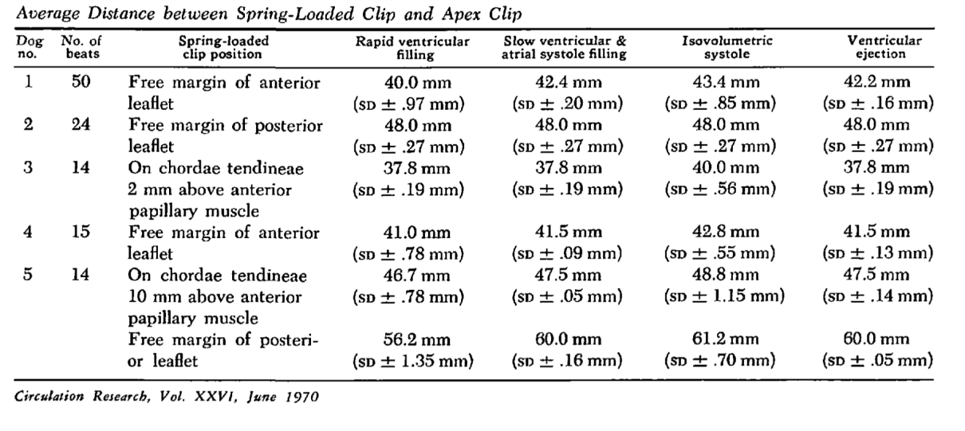
Figure 21: Shows change in length of CT in the left ventricle

Therefore, the peak force of the blood in the left ventricle was the tension used to establish the spring constant of the system. Figure 22 shows how the Box Model will compensate for mitral regurgitation. Figure 22 shows the general physiology of the left ventricle and how the device will compensate. The healthy heart has a natural CT that extends from the leaflet to the papillary muscle and prevents MR. The heart that has the snapped CT causes mitral regurgitation because the leaflet cannot effectively close. Without the chordae, the leaflet extends into the left atrium and causes mitral regurgitation. The two lower pictures of Figure 22 show the device in its relaxed and compressed state. The spring naturally wants to be relaxed and short. The force of the left ventricle extends the spring slightly. The steel chords connecting the device to the leaflet and papillary muscle do not change length.
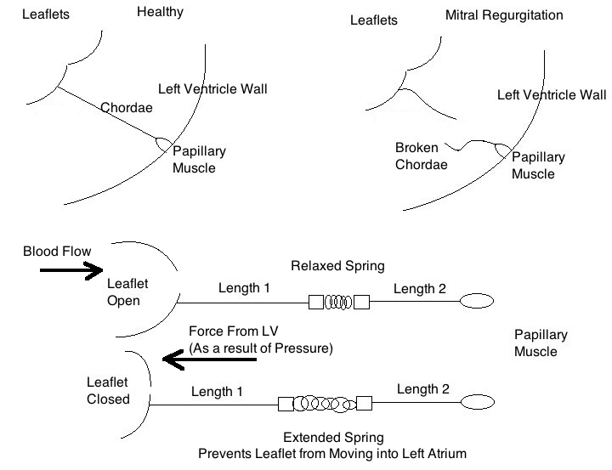
Figure 22: Shows how Box Model with spring components minimizes MR

Figure 23 shows the force of the blood entering the LV helping the spring return to its relaxed state. The peak pressure of blood in the LV was used to calculate the force extending the spring. Figure 23 shows how the force of blood causes the spring to relax, and the force of blood in the LV causes the spring to extend to the correct length to prevent mitral regurgitation. The arrows show the direction of the force that dominates the system and the change in length of the device.
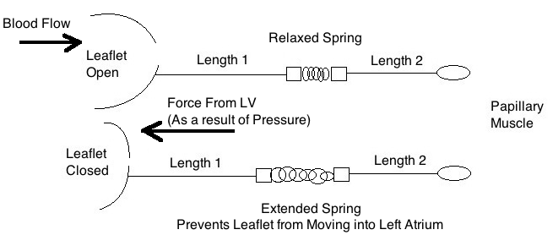
Figure 23: Force of Blood causing the mitral valve to open and shut

Table 1 shows the constants used to calculate the spring constant.
Table 1: Constants used to calculate the spring constant

Constant | Value
Change in Spring Length | 1 mm
Relaxed Spring Length | 1 mm
Total length of relaxed Device | 5 mm
Area of anterior leaflet | 3.8 cm²
Area of posterior leaflet | 7.6 cm²
Normal systolic blood pressure (normal person) | 120 mm Hg=15,998 Pa
Max systolic blood pressure (a person with hypertension) | 140 mm Hg=18,665 Pa
Equation 1: (P: pressure, F: force, A: cross sectional area)
Equation 2: (M: moments, x: length, P: pressure, A: cross sectional area)
Equation 3: (T: tension, τ: torque, L: length)
The leaflets are assumed to be a thin beam attached to the ventricle wall as a rigid body as Figure 24 shows. The torque is calculated as a step to determining tension in the CT attached to the leaflets.
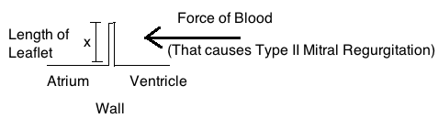
Figure 24: Leaflet modeled as thin beam for force diagram

Now we apply Equation 2: to establish the sum of moments on each leaflet.
Table 2: Constants of the anterior and posterior leaflet which are used to find Normal total and Max total torque

 | Area of leaflet | Normal systolic blood pressure | Max systolic blood pressure | Length of leaflet | Normal Total Torque | Max Total torque
Anterior Leaflet | 3.8 cm² | 15,998 Pa | 18,665 Pa | 1.3 cm | 0.079 Nm | 0.092 Nm
Posterior Leaflet | 7.6 cm² | 15,998 Pa | 18,665 Pa | 2.5 cm | 0.30 Nm | 0.35 Nm
Similarly, applying Equation 3: , gives us the tension on CT attached at the edge of the leaflets. The ACT will be anchored at the edge of the leaflet to allow for maximum prevention of mitral regurgitation.
Table 3: Normal and Max Tension in the Anterior and posterior leaflet

 | Normal torque | Max torque | Length of leaflet | Normal Tension | Max Tension
Anterior Leaflet | 0.079 Nm | 0.092 Nm | 1.3 cm | 6.08 N | 7 N
Posterior Leaflet | 0.30 Nm | 0.35 Nm | 2.5 cm | 12 N | 14 N

The posterior leaflet is the main leaflet involved in mitral regurgitation and therefore the leaflet considered through the remaining calculations. By the above calculations, for a hypertensive patient the tension needed to cause an extension of 1 mm must be 14 N of force. For a normal patient the tension needed to cause an extension of 1 mm must be 12 N.
Now, the spring constant to be used must be established.
Equation 4: (F: force, k: spring constant, Δx: change in length of the spring)
Table 4: Spring constants for patient with normal blood pressure and patient with hypertension

 | Normal Force | Max Force | Δx (Change in spring length) | Normal k (Spring constant) | Max k (Spring constant)
Posterior Leaflet | 12 N | 14 N | 1 mm | 12, 000 N/m | 14,000 N/m

The relaxed state of the spring occurs when the leaflet is open. Type II mitral regurgitation occurs when there is retrograde motion of blood into the left atrium caused by the leaflet moving in to the left atrium. The spring compensates for the damaged or severed chordae tendinae by completely closing the leaflet when the max force of LV blood pressure is reached and aid in opening as the force of blood into the LV increases.
The spring constants were calculated for both hypertensive and normal patients because there is a discrepancy in the force of blood in the LV between the two groups. The spring used for normal patients can safely be applied to patients with a blood pressure in the range of 110-130 mm Hg. The spring used for hypertensive patients can safely be applied to patients with a blood pressure in the range of 130-150 mm Hg.
Blood does not instantaneously enter the LV, and the spring adjusts to that by opening an amount proportional to the force of blood entering the LV. As the LV changes and the pressure differential favors a closed valve, the spring begins to extend and help the chordae form a completely closed valve to eliminate mitral regurgitation.

Design Schedule
Deadlines | Project to be Completed
2-Nov | Design Safe, Hardware Requirements, Force/Flow Diagrams
9-Nov | Last Weekly Report Due, Company Contact Information
16-Nov | Hardware Specifications, Calculations and Restrictions
23-Nov | Investigate prototyping
 | Create cost analysis
30-Nov | Peer Review Due
 | Course/Mentor/Client Reviews Due
7-Dec | Final Report
 | Final Oral Presentation
14-Dec | Poster Competition

Team Responsibilities

All members: design brainstorming, mapping out ideas, and mathematical calculations

- Kaitlin:
  - Describing knot tying device
  - Describing trap device
  - Presentation
- Brooke
  - Design specifications
  - Analysis of devices and design requirements
  - Pugh chart
- Tucker
  - CAD drawings
  - Description of Box model
  - Description of Shorts device

Appendix
ACT: artificial chordae tendineae
CT: chordae tendineae
MR: Mitral Regurgitation
PP: Prolypropylene
TEE: Transesophageal Echocardiography

Material Analysis

Gore-Tex
Specifications:
- Breaking strength: 1,000 g.
- Clip strength: 500-g threshold.
- Typically Gore-Tex suture diameter is 5.0 French (1.667 millimeters).
Gore-Tex can withstand the physiological conditions of the left ventricle, making it the most commonly used material for the ACT. Yet Gore-Tex sutures are difficult to maneuver and anchor to the leaflet and ventricle wall because they are not sturdy and have little grip. We used Gore-Tex clip and tear strength as our minimal criteria for our material for the ACT.

316L Stainless Steel
316L stainless steel is a low carbon steal and is biocompatible and resistant to corrosion. These are the two most important criteria for our cinching device. 316L stainless steel is the traditional choice for bare metal and drug eluting stents. Stents are comparable in size to our device so we believe this is a strong candidate in our materials to consider for the ACT.
- Biocompatible
- Strong (Tensile Strength 515 MPa, Rockwell Hardness 95)
- Durable: corrosive Resistant
- Easy to machine because of low carbon content
Composition:
Fe, <0.03% C, 16-18.5% Cr, 10-14% Ni, 2-3% Mo, <2% Mn, <1% Si, <0.045% P, <0.03% S
Properties:
Tensile Strength  (MPa) min | Yield Strength  0.2% Proof  (MPa) min | Elongation  (% in 50mm) min | Rockwell B (HR B) max Hardness | Density (kg/m³) | Elastic Modulus (GPa) | Brinell (HB) max Hardness
515 | 205 | 40 | 95 | 8000 | 193 | 217

L605 Cobalt Chromium
- Biocompatible
- Greater elasticity and strength than 316L Stainless Steel

MP35N Cobalt Nickel
- Biocompatible
- High Strength
- Toughness
- Ductility
- Corrosion resistance
We chose Gore-Tex for devices that need some flexibility and ACT that need to wrap and tie, as in the Knot Tying Device and Trap Device. We chose Gore-Tex for this use because it is a accepted material for ACT replacement.
We chose 316L stainless steel for the stiff ACT because it is biocompatible, durable, strong and easy to manufacture, which would reduce cost. All of these factors are criteria we looked for in the Pugh Chart of our device, and the other matierls do not have all four of these qualities.

References
(1) Anyanwu, Anelechi, Parwis Rahmanian, Farzan Filsoufi, and David Adams. "The Pathophysiology of Ischemic Mitral Regurgitation: Implications for Surgical and Percutaneous Intervention." Journal of Interventional Cardiology. 19.5 (2006): 78-86. Print.

(2) Feldman, Ted, Elyse Foster, Donald Glower, Saibal Kar, and Michael Rinaldi. "Percutaneous Repair or Surgery for Mitral Regurgitation." New England Journal of Medicine. 364.1395-1406 (2011): Print.

(3) Gaasch, WH. "Mitral RegurgitationOverview of the management of chronic mitral regurgitation." Mayo Clinic. Mayo Foundation for Medical Education and Research, 15 Sep 2011. Web. 25 Sep 2011.

(4) Gillinov, AM, and DM Cosgrove. "Mitral valve repair for degenerative disease." J Heart Valve Dis. (2002): 15-20. Print.

(5) Jackson, Jasper et al. “Knot Tying Device and Method”. United States Patent 6,171,317 B1. Jan 2001.

(6) Karas, Stephen, and Ronald C. Elkins. "Ventricular Papillary Muscles in Dogs Mechanism of Function of the Mitral Valve Leaflets, Chordae Tendineae and Left." American Heart Association: Circulation Research, June 1970. Web. 24 Oct. 2011. <http://circres.ahajournals.org/content/26/6/689.full.pdf>.

(7) Mesana, Thierry, Moheb Ibrahim, and Mark Hynes. "A Technique for Annular Plication to Facilitate Sliding Plasty After Extensive Mitral Valve Posterior Leaflet Resection." Annals of Thoracic Surgery. 79.2 (2005): 720-22. Print.

(8) "Stainless Steel - Grade 316 - Properties, Fabrication and Applications." AZoM™ - The A to Z of Materials and AZojomo - The "AZo Journal of Materials Online" Web. 24 Oct. 2011. <http://www.azom.com/article.aspx?ArticleID=863>.

